# GLAB 330.2.2 - Standard Deviation

Alacoque LeBlanc Date: 07-29-2025

Module 330.2.2 GLAB Assignment - Standard Deviation

# 

**Introduction:**

**Standard Deviation** **(*σ*)** in statistics, typically denoted by **σ**, is a measure of how much a data set varies (dispersion) between values in a set of data. The lower the standard deviation, the closer the data points tend to be to the mean (or expected value), **μ**. In this lab, we will demonstrate how to calculate the standard deviation.

## Learning Objective:

By the end of this lab learners will be able to calculate the standard deviation.

**Given Dataset**

You’ve just moved into your new house and you want to add some color and style to each room with a beautiful plant. The following data set represents the most popular household plants for new homeowners.

|  |
| --- |
| **Name of Plant Number of Plants (X)** |
| **Lily 4** |
| **Snake 2** |
| **Spider 4** |
| **Aloe Vera 6** |
| **Ivy 6** |
| **Pothos 6** |
| **Money 15** |
| **Orchid 5** |

1. **Calculate the mean (average) of the data set:**

**X = (4+2+4+6+6+6+15+5)/8 = 48/8 = 6**

**Calculate the squared differences from the mean for each data point:**

**(4-6)^2 = (-2)^2 = 4**

**(2-6)^2 = (-4)^2 = 16**

**(4-6)^2 = (-2)^2 = 4**

**(6-6)^2 = (0)^2 = 0**

**(6-6)^2 = (0)^2 = 0**

**(6-6)^2 = (0)^2 = 0**

**(15-6)^2 = (9)^2 = 81**

**(5-6)^2 = (-1)^2 = 1**

**Calculate the average of these squared differences (variance):**

**Variance = (4+16+4+0+0+0+81+1)/8 =  106/8 = 13.25**

**Take the square root of the variance to get the standard deviation:**

**sqrt (13.25) = 3.64005494**

The standard deviation of the number plants for new homeowners is **3.6.** This means that on average, the number of plants owned by each homeowner deviates from the mean by **3.6.**

**Instructions:**

Here are the steps to calculate the standard deviation:

1. **Calculate the mean (average) of the data set:**



1. **Calculate the squared differences from the mean for each data point:**

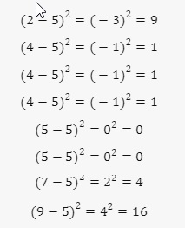

1. **Calculate the average of these squared differences (variance):**

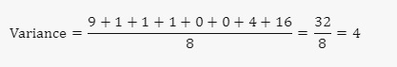

1. **Take the square root of the variance to get the standard deviation:**

## 

The standard deviation of the number of books read by these students is **2**. This means that on average, the number of books read by each student deviates from the mean by **2** books.

**Canvas Submission Instructions:**

* Upload your project to your GitHub account without setting it to private.
* Utilize the `README` file for any necessary additional instructions.
* Incorporate suitable comments throughout your project.
* Share the GitHub link on Canvas by clicking on the "Start Assignment" button located in the top-right corner of the Assignment page.